

Project Report

**Project:** Cymed – Online Medical Service Providing System

**Group:** 07

**Course:** CSE482L – Internet and Web Technology Lab

**Section:** 02

**Course Instructor:** Md. Naqib Imtiaz Hussain (NQH)

**Lab Instructor:** Farjana Alam

**Submission Date:** 30 August 2022

|  |  |  |
| --- | --- | --- |
| Name | ID | Email |
| Mohammad Nabiluzzaman Neloy | 1831251042 | [mohammad.nabiluzzaman@northsouth.edu](mailto:mohammad.nabiluzzaman@northsouth.edu) |
| Rafid Ahmed | 1831395642 | [rafid.ahmed@northsouth.edu](mailto:rafid.ahmed@northsouth.edu) |

*Table of Contents*

*1. Abstract …………………………………………………………………………………………………………………………. 3*

*2. Introduction ……………………………………………………………………………………………………………..……. 3*

*3. Background and Product Context ………………………………………………………………………………..…. 3*

*4. Use-Cases (Patient’s Panel) ………………………………………………………………………………………….... 4*

*4.1 Registration ……………………………………………………………………………………………………… 5*

*4.2 Login ….………………………………………………………………………………………………………….… 5*

*4.3 Profile ……………………………………………………………………………………………………………… 6*

*4.4 Make Appointment ………………………………………………………………………………………….. 6*

*4.5 Appointments ………………………………………………………………………………………………….. 6*

*4.6 Prescriptions ……………………………………………………………………………………………………. 6*

*5. Use-Cases (Doctor’s Panel) ………………………………………………………………………………………….... 7*

*5.1 Login …………………………………………………………………………………………………………..…… 7*

*5.2 Profile ……………………………………………………………………………………………………………… 8*

*5.3 Appointments ………………………………………………………………………………………………….. 8*

*5.4 Prescribe ….…………………………….……………………………………………………………………….. 8*

*6. Use-Cases (Admin’s Panel) ……………………………………………………………………………………………. 9*

*6.1 Registration …………………………………………………………………………………………………….. 9*

*6.2 Login ……………………………………………………………………………………………………………….. 10*

*6.3 Profile ……………………………………………………………………………………………………………... 10*

*6.4 Add Doctor ………………………………………………………………………………………………………. 10*

*6.5 Remove Doctor ……………………………………………………………………………………………….. 11*

*6.6 AVK …………………………………………………………………………………………………………………. 11*

*7. Software ……………………………………………………………………………………………………………………..… 11*

*8. Technologies ………………………………………………………………………………………………………………... 12*

*9. Gantt Chart …………………………………………………………………………………………………………………... 12*

*10. Web Hosting ……………………………………………………………………………………………………………... 13*

*11. Local Installation ………………………………………………………………………………………………………... 13*

1. Abstract

Medical facilities have been developing daily, and the necessity of providing the best possible medical care to the customers has been the primary goal for most health care facilities. In the modern world of the Internet, it is still observed that many medical care facilities provide handwritten prescriptions, and printed vaccine certifications. This creates a hustle in keeping up the lifetime medical records of a patient in one single place and also increases paperwork. Cymed is an online medical service providing platform where doctors can provide digital prescriptions to their customers, and keep track of their appointments right away from their doctor account. Additionally, it also provides the facility for a patient to make an appointment with a doctor, check their prescriptions, and search for their required specialist to know more details about them. Admins also have access to the system and they have the ability to add/remove doctors and generate AVK (Admin Verification Keys).

2. Introduction

Cymed is a medical service providing, web-application, that facilitates the process of scheduling appointments, generating online prescriptions, and keeping lifetime prescription records.

3. Background and Product Context

In the modern world of the Internet, many new technologies are being used to move traditional procedures into the digital world. Medical technologies have also been developing throughout the years, however, there are still many medicare services that still follow the old system of prescription writing. It has been observed that many patients struggle to understand the doctors' handwriting. Furthermore, a hard copy of the prescription may not be feasible as it increases the paperwork, and keeping all the lifetime records might create a hustle. Medical records are really essential as many injuries or medical cases require previous medical records for better treatment, so keeping all the records in one place would be the best possible solution. In addition, the procedure of making an appointment has also been made easy for the patients in this system. Following all the possible cases above, our project “Cymed” provides all the best possible solutions to the problems mentioned above just right through an online web application platform.

4. Use-Cases (Patient’s Panel)

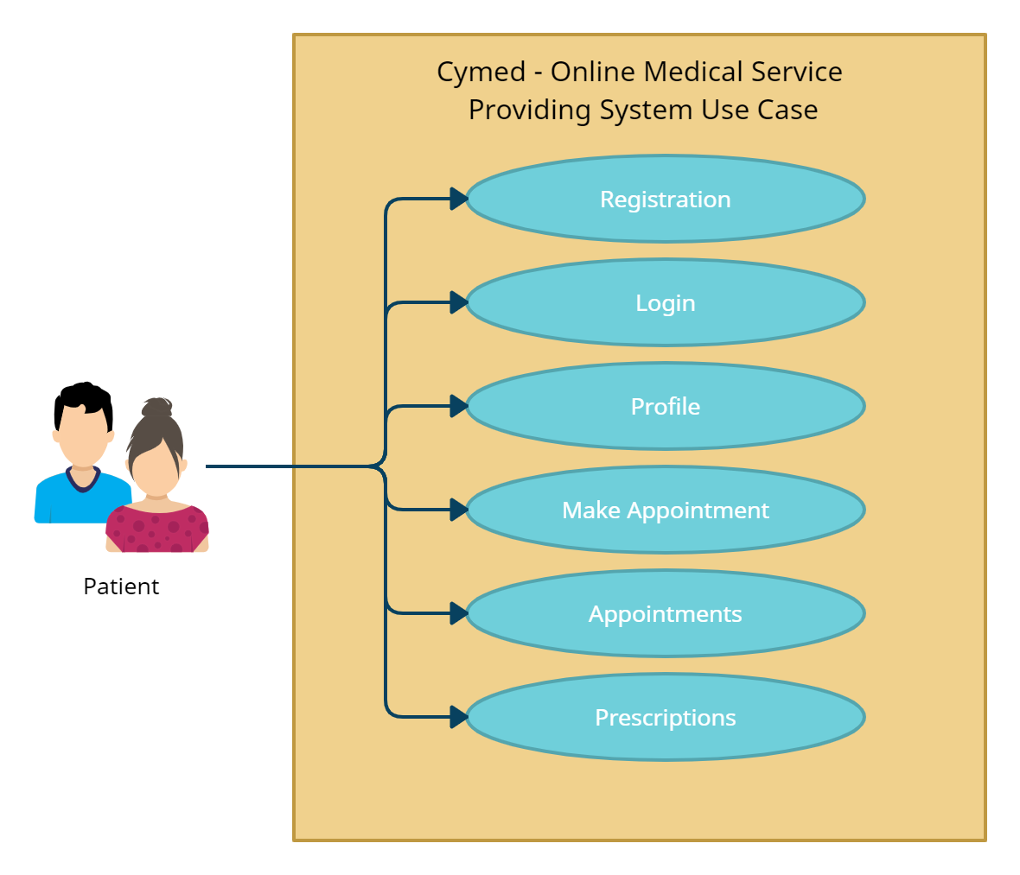

### *4.1 Registration*

Patients can register themselves into the system by simply providing several information such as first name, last name, date of birth, gender, contact number, email, and password. Once the registration is complete the patient will be assigned a 12-digit patient ID starting with 3.

Patients can also register themselves through google registration.

Home

Patient Registration

Email Existence

Form Validation

Password Confirmation

Patient Registration

Google OAuth

Obtain Email

Database Check

Home

### *4.2 Login*

Patients can log in to their respective accounts by entering their email and password only.

Patients can also login directly using their Gmail account. Before that they need to be registered into the system.

Patient Profile

Email Check

Password Check

Patient Login

Patient Login

Google OAuth

Email Check

Patient Profile

### *4.3 Profile*

The Profile section displays all the details about the patient that he/she entered during their registration. It is the initial tab that will open when the patient login into their account.

### *4.4 Make Appointment*

The Make Appointment section allows the patients to make an appointment with their respective doctors. A patient can make no more than a single appointment for a particular date. The process to make an appointment is simple. The patient needs to select a specialist they require for their treatment, name of the doctor, the day of appointment, date, and time.

Select Date

Select Day

Select Doctor

Select Specialist

Make Appointment

Select Time

Appointments

### *4.5 Appointments*

The Appointments section shows the appointment details for all the upcoming appointments that the patient has made. It shows the appointment number, serial number, doctor name, date, and time. A “Cancel” button is provided with every appointment so that the patient can cancel their appointment anytime whenever required.

### *4.6 Prescriptions*

The Prescription section shows all the available prescriptions for the particular patient. At the initial point, it shows the prescription number, prescription ID, appointment ID, doctor name, specialist, and date. On clicking the “details” button beside every appointment, the patient will be able to see the whole prescription.

5. Use-Cases (Doctor’s Panel)

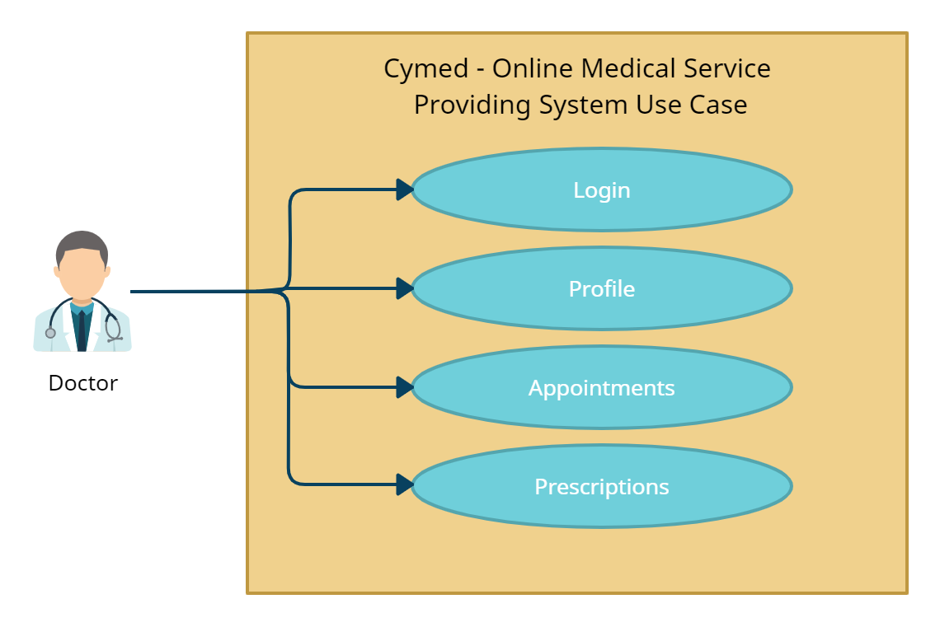

### *5.1 Login*

Doctors will be able to login into their account by simply entering their “initial” provided by the admin and password.

Doctor Login

Initial Check

Password Check

Doctor Profile

### *5.2 Profile*

The Profile section displays all the details about the doctor that he/she has provided to the admin during their registration. It is the initial tab that will open when the doctor login into their account.

### *5.3 Appointments*

The Appointments section shows the appointment details for all the upcoming appointments. It shows the appointment number, serial number, patient name, date, and time.

### *5.4 Prescribe*

A “Prescribe” button is provided with every appointment so that the doctor can create a prescription for the patient during the appointment. In the prescription, the patient’s name and age are given at the beginning. In the following part, the prescription has four text fields: Symptoms, Previous Operations or Sickness, Tests, and Medicines. The doctor has to fill up these fields and press the “Prescribe” to complete the prescription. A confirmation message will pop up before the prescription is successfully submitted.

Go Back

Appointments

Prescribe

Complete Form

Appointments

6. Use-Cases (Admin’s Panel)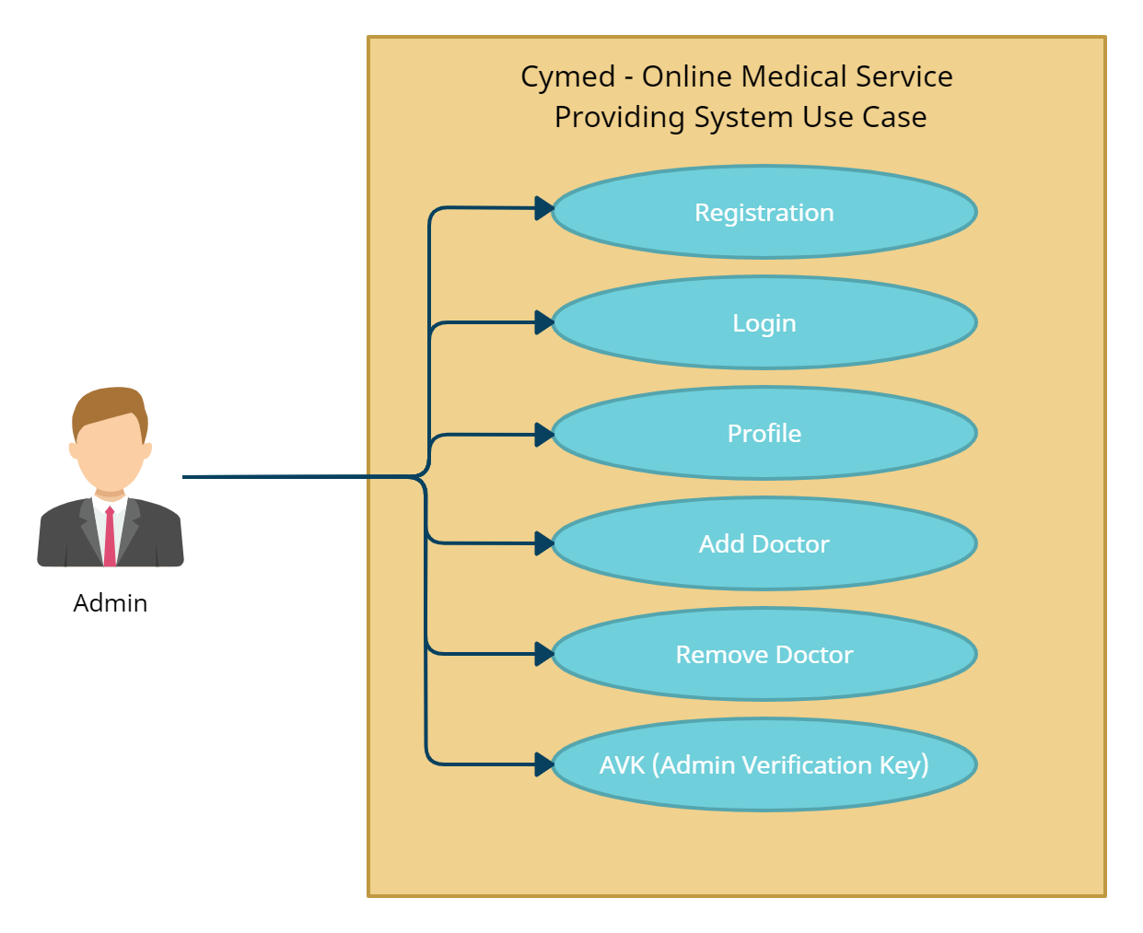

### *6.1 Registration*

Admins will be able to register themselves into the system by providing their first name, last name, date of birth, gender, admin verification key, email, contact number, password, and confirmation password. Once the registration is complete the system will automatically generate a 12-digit admin ID starting with 1.

Admin Registration

Password Confirmation

Email Check

AVK Check

Form Validation

Home

### *6.2 Login*

Admins will be able to login into their respective accounts by simply entering the last 7 digits of their admin ID and password.

Admin Login

Admin ID

Password Check

Admin Profile

### *6.3 Profile*

The Profile section displays all the details about the admin that he/she has provided during their registration. It is the initial tab that will open when the admin login into their account.

### *6.4 Add Doctor*

Admins will be able to add a doctor to the system by entering the following details: first name, last name, date of birth, gender, contact number, designation, qualification, university, experience, work days, start time, finish time, doctor initial, email, and password.

Add Doctor

Form Validation

Email Check

Initial Check

Password Confirmation

Admin Profile

### *6.5 Remove Doctor*

Admins will be able to remove a doctor from the system by just entering the complete 12-digit ID of a doctor.

Remove Doctor

Remove Doctor

Doctor ID Check

### *6.6 AVK (Admin Verification Key)*

Admins will have the ability to generate an Admin Verification Key which will consist of 7 random characters out of the uppercase or lowercase letters and digit from 0 to 9. This AVK is provided to new admins who will register themselves into the system. Without the AVK no one can register themselves as an admin. An AVK is deleted from the database once registration is complete using it. The same AVK cannot be used twice.

Random String (AVK) Generated

Generate AVK

Admin Profile

7. Software

* Version Control System - Git
* Repository Hosting Service - Bitbucket
* Integrated Development Environment IDE - VS Code
* Web-Server (SQL Database XAMPP)
* Infinity Free (Deployment)
* Google Docs
* Microsoft Office
* Creately (Diagrams)

8. Technologies

* HTML
* CSS
* Bootstrap
* JavaScript
* JQuery
* Ajax
* PHP
* MySQL

**9. Gantt Chart**

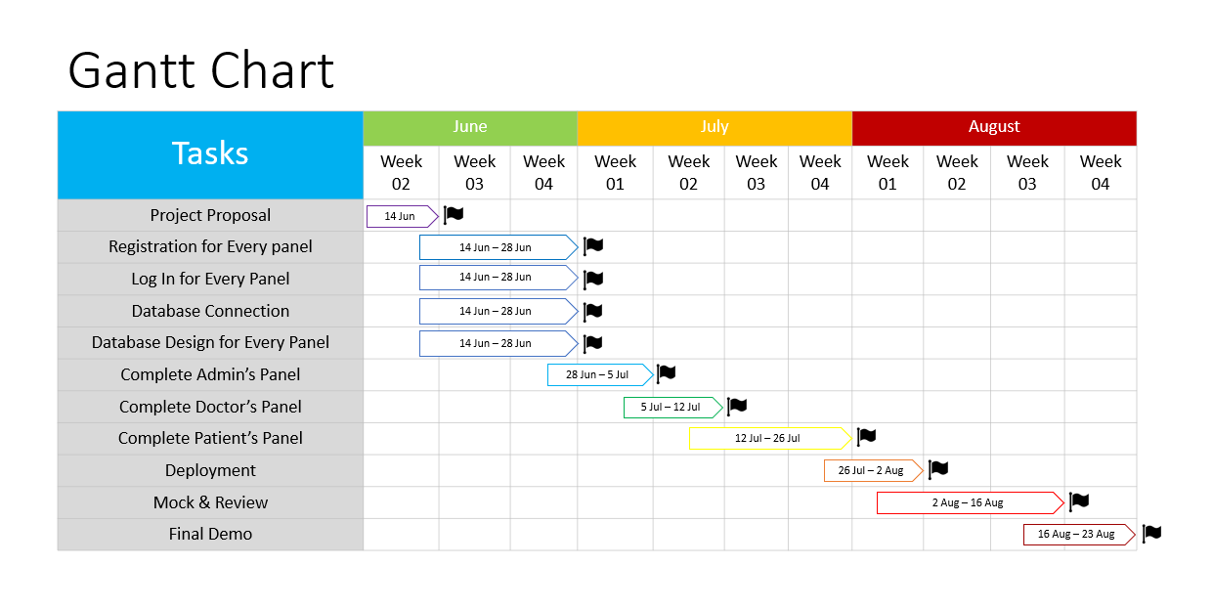

**10. Web Hosting**

For the hosting our project we have used a free hosting service that is provided by “Infinity Free”. Both the domain and hosting has been provided by this website completely free. However, there were some limitations that we have faced while deploying our project to this system. The uploads were not fulfilled completely all at a time. Keeping that in mind we also tried to deploy all the files individually into the “htdocs” folder of the file management system of the CPanel. Even after that, we faced some rendering issues on the front-end side.

Our projects seem to be working fine for maximum of the back-end functionalities, except the Google Login and Google Registration for the Patient Panel. These two functionalities require google API libraries which we could upload into the file manager of our host.

This is the link to our hosted system is <http://cymed.great-site.net/>.

As this is a free hosting service, we actually can expect much out of it. We also tried other hosting service like <https://freehosting.com/>, <https://googiehost.com/index.html>, <https://www.gigarocket.net/>, etc. Nevertheless, these hosting services required credit card credentials which we actually don’t have access. The same goes for the free hosting available on Google Cloud or AWS Web Hosting Services.

**11. Local Installation**

To locally install our system, please refer to the “instructions.txt” file available in the “Project Folder”. A detailed information about the installation process is provided in this file.